ARYAMAN MISHRA

19BCE1027

Phone:6390159999

1) In Chennai Corporation house tax is levied annually. If the house is under owner’s occupation then the tax is levied as 0.5% of the total value of the property. If the property is rented, then 10% of the annual rent is the annual house tax for the property.Define a class House and implement the taxing procedure. You program should be repeat the process till the user wishes to continue.

import java.util.\*;

class House

{

double price,rent;

House(double a,double b)

{

price=a;

rent=b;

}

public double owner()

{

return ((0.50/100)\*price);

}

public double renter()

{

return ((10/100)\*rent);

}

}

class HouseBox

{

public static void main(String[] args)

{

Scanner sc=new Scanner(System.in);

double p,r,t,tax=0.00d;

int x,choice=1;

System.out.println("Enter total value of the property.");

p=sc.nextDouble();

System.out.println("Enter rent value of the property.");

r=sc.nextDouble();

House ob=new House(p,r);

while(choice!=0)

{

System.out.println("Press 1 if owner occupied the house,2 if it was a rented property.");

x=sc.nextInt();

if(x==1)

{

t=ob.owner();

tax=tax+t;

}

else

{

t=ob.renter();

tax=tax+t;

}

System.out.println("You want to evaluate for next year,press 1 else press 0 to end taxing procedure.");

choice=sc.nextInt();

}

System.out.println("Tax="+tax);

}

}

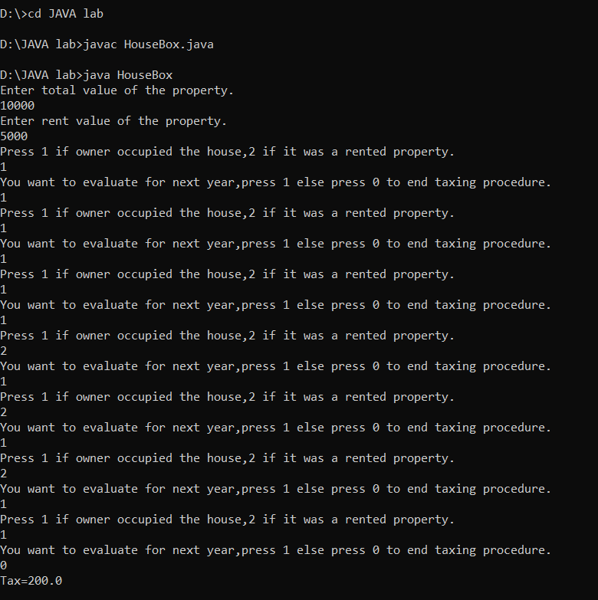

2) In a housing board colony the houses are constructed such that it has a bed room, drawing room, a hall, dining room, and a kitchen. It also has a television kept in the hall. Create a class with the following properties: Door No, Total ground area of the plot in which house is located, Date of Construction. Also display the details of house using a method.

import java.util.Scanner;

class Colony {

int door;

double plot;

String datecon;

Colony(int a,double b,String c) {

door=a;

plot=b;

datecon=c;

}

public void display()

{

System.out.println("Door Number:"+door);

System.out.println("Total ground area of the plot:"+plot);

System.out.println("Date of Construction:"+datecon);

}

}

class ColonyBox {

public static void main(String[] args) {

Scanner sc = new Scanner(System.in);

System.out.print("Please enter Door Number: ");

int x=sc.nextInt();

System.out.print("Please enter Ground area: " );

double y = sc.nextDouble();

System.out.print("Please enter Date of Construction: " );

String z=sc.next();

sc.nextLine();

Colony ob=new Colony(x,y,z);

ob.display();

}

}

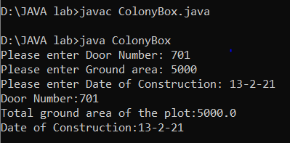

3)

In an educational institution, one of the M.Tech class with 30 students have the following properties: Roll number, Name, Date of Birth, weight, height. Write a suitable constructor and a method to display the details of all the students and also display roll numbers of the students who are 19 years old or more with weight above 75 kg but height less than 172 cm.

import java.util.\*;

class MTech

{

int roll,age;

String name;

double weight,height;

MTech(int a,String b,int c,double d,double e)

{

roll=a;

name=b;

age=c;

weight=d;

height=e;

}

public void display()

{

System.out.println("Roll Number:"+roll);

System.out.println("Name:"+name);

System.out.println("Date of Birth(Age):"+age);

System.out.println("Weight"+weight);

System.out.println("Height"+height);

}

public void check()

{

if(age>=19 && weight>=75.00 && height<172.00)

{

System.out.println("Roll Number:"+roll);

}

}

}

class MTechBox

{

public static void main(String args[])

{

Scanner sc=new Scanner(System.in);

System.out.println("Enter number of students.E.g. 30,5");

int n=sc.nextInt();

int v,x;

String w;

double y,z;

MTech[] a=new MTech[n];

System.out.println("Enter Roll No,Name,DOB,Weight and Height.");

for(int i=0;i<n;i++)

{

System.out.println("Enter Roll No.");

v=sc.nextInt();

System.out.println("Enter Name.");

w=sc.next();

System.out.println("Enter DOB(age).");

x=sc.nextInt();

System.out.println("Enter Weight");

y=sc.nextDouble();

System.out.println("Enter Height.");

z=sc.nextDouble();

a[i]=new MTech(v,w,x,y,z);

}

for(int i=0;i<n;i++)

{

a[i].display();

}

System.out.println("Roll Numbers numbers of the students who are 19 years old or more with weight above 75 kg but height less than 172 cm.");

for(int i=0;i<n;i++)

{

a[i].check();

}

}

}

